**Nitte Meenakshi Institute of Technology**

**Department of Computer Science and Engineering**

**18CSE751 Introduction to Machine Learning**

**Learning Activity Proposal**

**Personality Type Prediction**

**Gagan R, Monish K and A S Prithvi Raj**

**Abstract**

**Myers Briggs Type Indicator (MBTI) is a personality type system that divides everyone into 16 distinct personality types across 4 axes:**

**Introversion (I) –Extroversion(E)**

**Intuition (N) – Sensing (S)**

**Thinking (T) – Feeling (F) Judging (J) – Perceiving(P)**

**For example, someone who prefers introversion, intuition, thinking and perceiving would be labelled as INTP in the MBTI system. Based on the posts and searches made by a user, their personality type can be determined. It is used in businesses, social sites, for fun, for research and lots more. MBTI sorts for preferences or behavior and does not measure trait, ability, or character. The 16 personality types of MTBI are listed below in the form of a table.**

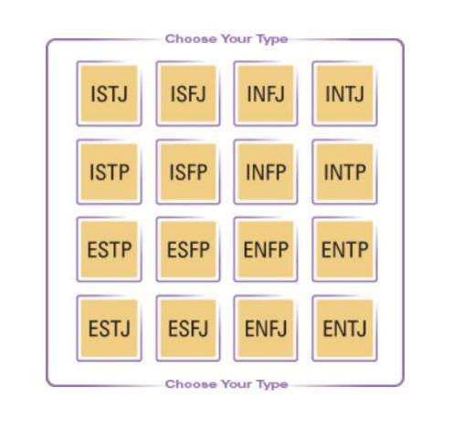

**Introduction**

**Machine learning is a subfield of artificial intelligence which is broadly defined as the capability of a machine to imitate intelligent human behavior. It allows machines to become more accurate at predicting outcomes without being explicitly programmed to do so.**

**Theory of MTBI: Random variation in behavior is quite orderly and consistent, being due to basic differences in the ways individuals prefer to use their perception and judgment. If people differ systematically in what they perceive and how they reach conclusions, then it is reasonable for them to differ correspondingly in their interests, reactions, values, motivations, and skills.**

**Course Coordinator: Dr. Vani 1**

**Data Set**

**The dataset contains over 8600 rows of data where each row contains:**

**type - Personality type (4 letter MBTI code)**

**posts - Last 50 things a user has posted/searched (Each entry separated by ‘|||’)**

**The dataset needs to be preprocessed by separating each post/search entry. It also contains links to YouTube videos and webpages whose content can be taken to predict the personality type. Link to dataset: https://www.kaggle.com/datasnaek/mbti-type**

**Machine Learning Methods**

**The Machine Learning methods that will be applied on the above dataset are as follows:**

1. **CART**
2. **Support Vector Machine (SVM)**

**CART: The CART algorithm is a type of classification algorithm that is required to build a decision tree on the basis of Gini’s impurity index. It is a basic machine learning algorithm and provides a wide variety of use cases.**

**Its advantages over other decision tree classifiers are:**

* **It is non-parametric.**
* **Outliers doesn’t have much effect**
* **Can use the same attribute multiple time.**

**SVM: It is a linear model for classification and regression problems based on the margin maximization principle. It constructs a hyperplane or a set of hyperplanes in a high dimensional space to classify datapoints.** **It can also perform non-linear classification by using kernel trick which implicitly maps the inputs** **into high-dimensional feature spaces.**

**Its advantages are:**

* **Effective in higher dimensional spaces**
* **Can perform non-linear classification**
* **Relatively memory efficient**

**Assessment**

**Accuracy: It is the fraction of predictions that our model has got right.**

**Accuracy =** **Number of correct predictions**

**Total number of predictions**

**Precision: It is the quality of positive predictions made by our model.**

**Precision =** **Number of true positives**

**Total number of positives**

**F1 Score: Weighted average of precision and recall. Used to compare two different classifiers.**

**F1 Score =** **2 * Precision * Recall**

**Precision + Recall**

**Presentation and Visualization**

**Determined personality type for each test sample (MBTI code) Percentage of top MBTI codes matching with the user**

**Overall accuracy, precision and F1 score of each model**

**Course Coordinator: Dr. Vani V** **2**

**Roles**

* **Gagan R - Proposal documentation, some modules of SVM**
* **Monish K - Preprocessing, some modules of CART and SVM**
* **A S Prithvi Raj – Preprocessing, part of report documentation**

**Schedule**

**Date** **Tasks**

**20/12/21** **Proposal documentation**

**02/01/22** **Preprocessing of dataset**

**09/01/22** **Implementation of models**

**17/01/22** **Assessments, results, and report**

**Bibliography**

1. **https://www.myersbriggs.org/my-mbti-personality-type/**
2. **https://machinelearningmastery.com/classification-and-regression-trees-for-machine-learning**
3. **https://en.wikipedia.org/wiki/Support-vector_machine**

**Course Coordinator: Dr. Vani V** **3**